**HW2---BUAI 434---Due by Midnight on Tuesday October 4th**

(This HW cannot be done in group. You should do it alone.)

Use the file named HW2.twbx available on CANVAS for the following exercises. For each Exercise, create a new worksheet/dashboard in the file HW2.twbx and name it “Exercise X-Y” for exercise number X part Y. Upload on CANVAS:

1- your final twbx file. and

2- An MS Word file. Export the Image of each of the Worksheet in the MS Word file. Use Worksheet/Export/Image in Tableau to do that.

**Exercise 1**: Produce the following display.

A world map that shows shipping cost of each country by color. Use Normal Style for map layer. Show country name and total shipping costs on the map.

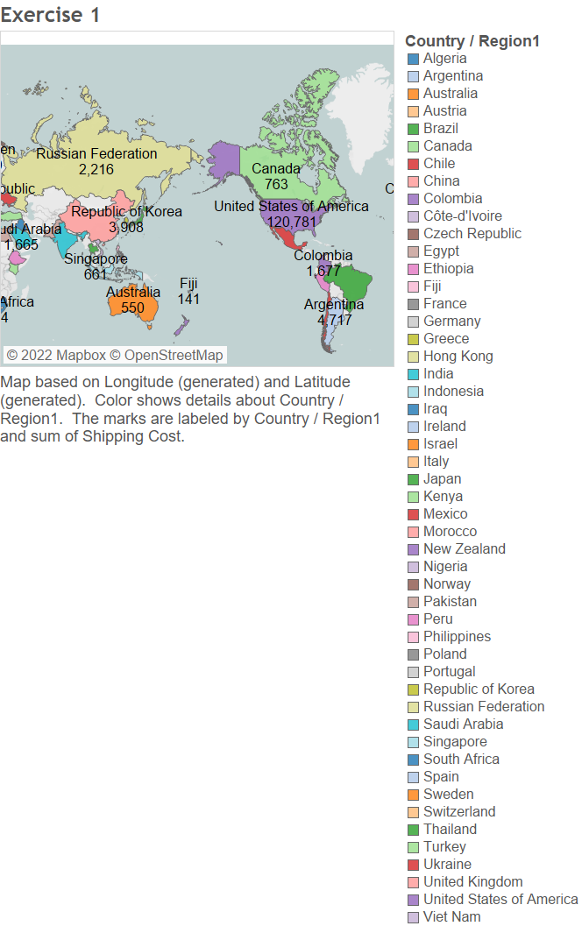

**Exercise 2**: Create a crosstab (regular table), a heatmap, and a highlight map (save them under the worksheet names Exercise 2-Crosstab, Exercise 2-heatmap , Exercise 2-highlight map) showing percentage median discounts provided to customers in the months of 2013 (across the top) sliced by Region and Order Priority (respectively) in Rows.

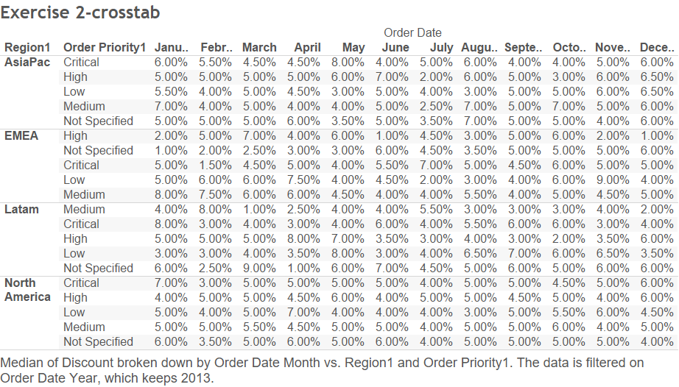

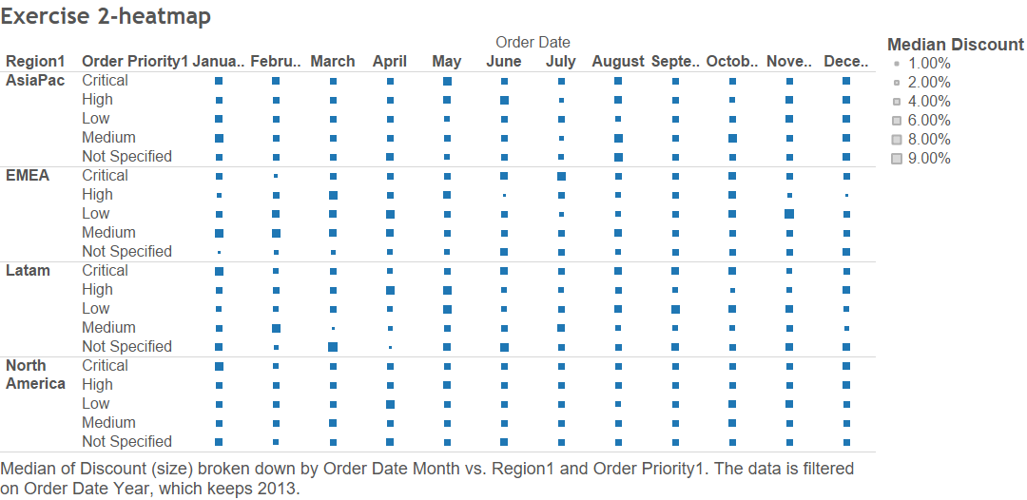

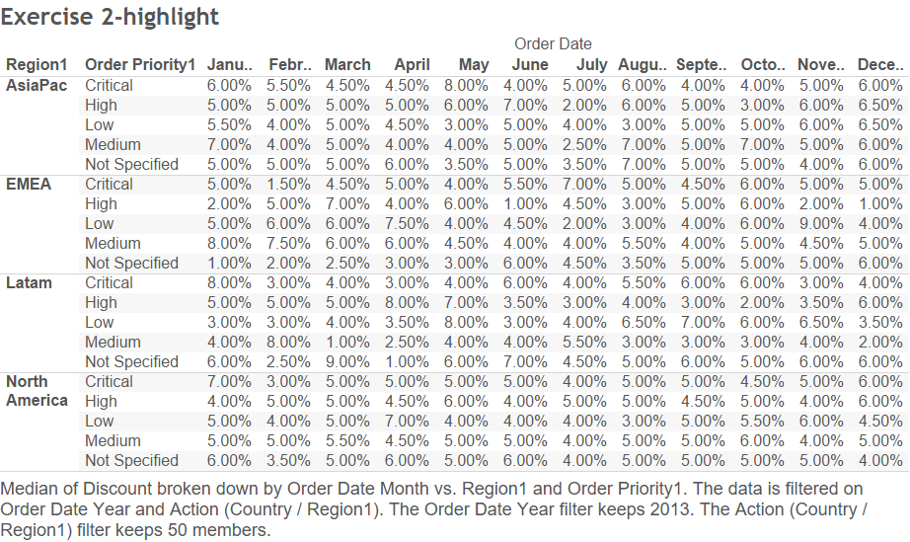

**Exercise 3**: Create a line chart showing what percentage of total cost is due to shipping costs over time (years of Order Date). Use Calculation and Aggregation on Profit, Sales, and Shipping Cost to get the percentage.

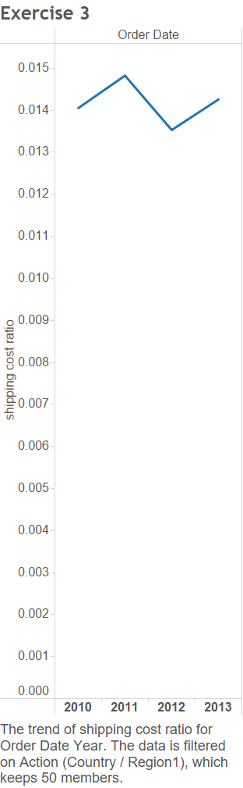

**Exercise 4**: Develop the following view.

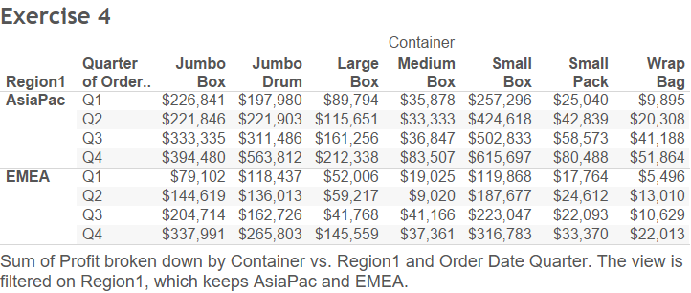

**Exercise 5**: Develop a map view showing a pie chart on every US state that has a total profit exceeding $120,000. The pie chart should present the distribution of total profit for different Departments. Enlarge the pie charts on the map to them visible and list the name of the state besides the pie chart. Hint: only 7 states qualify to get a pie chart.

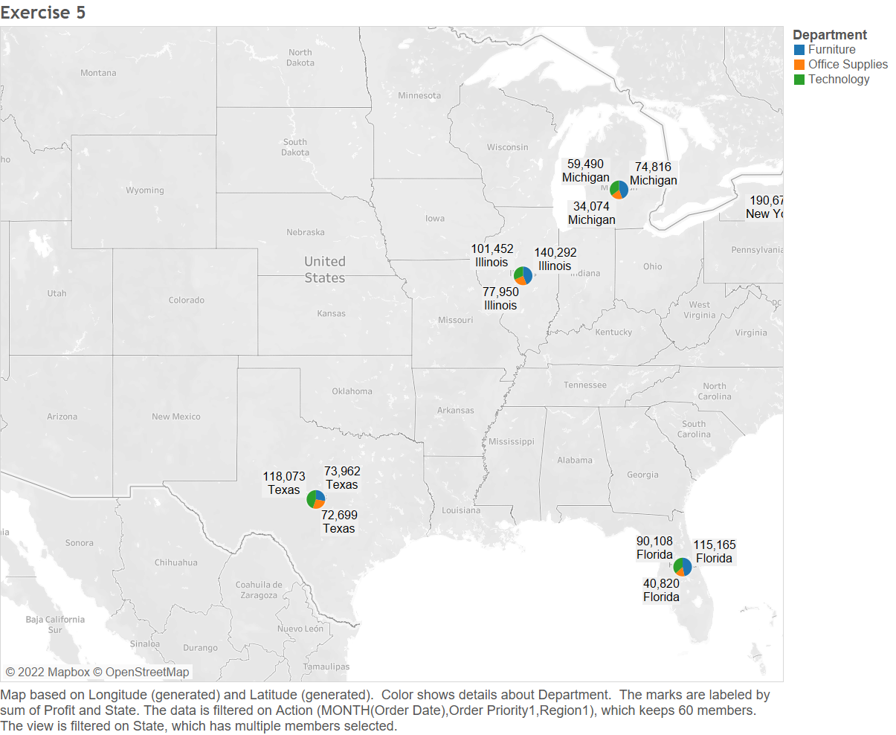

**Exercise 6**: Create a dashboard of your own choosing for the data given. The focus of the dashboard should be about presenting interesting data about Shipping Costs. The dashboard should have at least 3 graphical objects, one of which a map. Use a Filter, URL, and Highlight Action on the dashboard.

